**KPI’s Requirement**

1. **Total Revenue:** The sum of the total price of all pizza orders.

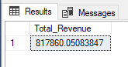 SELECT SUM(total_price) AS Total_Revenue FROM pizza_sales;

1. **Average Order Value:** The average amount spent per order, calculated by dividing the total revenue by the total number of orders.

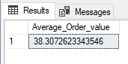 SELECT SUM(total_price)/COUNT(DISTINCT order_id) AS Average_Order_value FROM pizza_sales;

1. **Total Pizzas Sold:** The sum of quantities of all pizzas sold.

SELECT SUM(quantity) AS Total_Pizzas_Sold FROM pizza_sales;

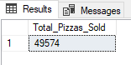

1. **Total Orders:** The total number of orders placed.

SELECT COUNT(DISTINCT order_id) AS Total_Orders FROM pizza_sales;

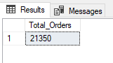

1. **Average Pizzas Per Order:** The average number of pizzas sold per order, calculated by dividing the total number of pizzas sold by the total number of orders.

SELECT CAST(CAST(SUM(quantity) AS decimal(10,2))/CAST(COUNT(DISTINCT order_id) AS decimal(10,2)) AS decimal(10,2)) AS Average_Pizzas_Per_Order FROM pizza_sales;

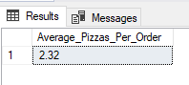

1. **Daily Trend for Total Orders:**

Create a bar chat that displays the daily trend of total orders over a specific time period. This chart will help us to identify any patterns or fluctuations in order volumes on daily basis.

SELECT DATENAME(DW,order_date) AS Order_Day, COUNT(DISTINCT order_id) AS Total_Orders FROM pizza_sales

GROUP BY DATENAME(DW,order_date);

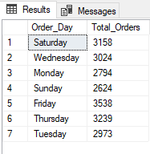

1. **Monthly Trend for Total Orders:**

Create an area chart that illustrates the Monthly trend of total orders. This chart will allow us to identify peak periods of high order activity.

SELECT DATENAME(MONTH,order_date) AS Month_Name, COUNT(DISTINCT order_id) AS Total_Orders FROM pizza_sales

GROUP BY DATENAME(MONTH,order_date)

ORDER BY Total_Orders DESC;

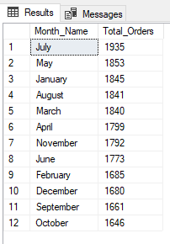

1. **Percentage of Sales by Pizza Category:**

Create a pie chart that shows the distribution of sales across different pizza categories. This chart will provide insights into the popularity of various pizza categories and their contribution to overall sales.

SELECT pizza_category,CAST(SUM(total_price) AS DECIMAL(10,2)) AS Total_Sales,CAST(SUM(total_price) * 100 / (SELECT SUM(total_price) FROM pizza_sales) AS decimal(10,2)) AS PCT FROM pizza_sales

GROUP BY pizza_category

ORDER BY PCT DESC;

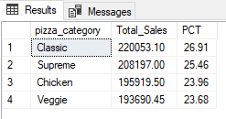

1. **Percentage of Sales by Pizza Size:**

Generate a pie chart that represents the percentage of sales attributed to different pizza sizes. This chart will help us understand customer preferences for pizza sizes and their impact on sales.

SELECT pizza_size,CAST(SUM(total_price) AS DECIMAL(10,2)) AS Total_Sales,CAST(SUM(total_price) * 100 / (SELECT SUM(total_price) FROM pizza_sales) AS decimal(10,2)) AS PCT FROM pizza_sales

GROUP BY pizza_size

ORDER BY PCT DESC;

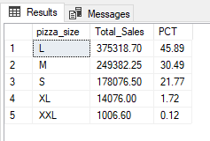

1. **Total Pizzas Sold by Pizza Category:**

Create a funnel chart that presents the total number of pizzas sold for each pizza category. This chart will allow us to compare the sales performance of different pizza categories.

SELECT pizza_category, SUM(quantity) AS Total_Quantity_Sold FROM pizza_sales

GROUP BY pizza_category

ORDER BY Total_Quantity_Sold DESC;

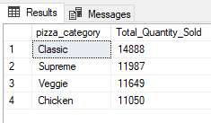

1. **Top 5 Best Sellers by Revenue, Total Quantity and Total Orders**

Create a bar chart highlighting the top 5 best-selling pizzas based on the Revenue, Total Quantity, Total Orders. This chart will help us identify the most popular pizza options.

**Top 5 Best Sellers by Revenue**

SELECT TOP 5 pizza_name,SUM(total_price) AS Total_Revenue FROM pizza_sales

GROUP BY pizza_name

ORDER BY Total_Revenue DESC;

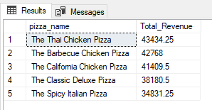

**Top 5 Best Sellers by Total Quantity**

SELECT TOP 5 pizza_name,SUM(quantity) AS Total_Quantity FROM pizza_sales

GROUP BY pizza_name

ORDER BY Total_Quantity DESC;

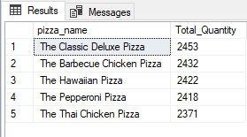

**Top 5 Best Sellers by Total Orders**

SELECT TOP 5 pizza_name,COUNT(DISTINCT order_id) AS Total_Orders FROM pizza_sales

GROUP BY pizza_name

ORDER BY Total_Orders DESC;

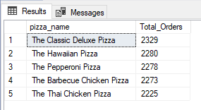

1. **Bottom 5 Worst Sellers by Revenue, Total Quantity and Total Orders**

Create a bar chart highlighting the bottom 5 worst-selling pizzas based on the Revenue, Total Quantity, Total Orders. This chart will enable us to identify underperforming or less popular pizza options.

**Bottom 5 Worst Sellers by Revenue**

SELECT TOP 5 pizza_name,SUM(total_price) AS Total_Revenue FROM pizza_sales

GROUP BY pizza_name

ORDER BY Total_Revenue ASC;

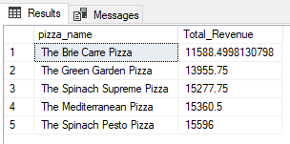

**Bottom 5 Worst Sellers by Total Quantity**

SELECT TOP 5 pizza_name,SUM(quantity) AS Total_Quantity FROM pizza_sales

GROUP BY pizza_name

ORDER BY Total_Quantity ASC;

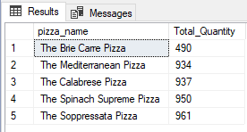

**Bottom 5 Worst Sellers by Total Orders**

SELECT TOP 5 pizza_name,COUNT(DISTINCT order_id) AS Total_Orders FROM pizza_sales

GROUP BY pizza_name

ORDER BY Total_Orders ASC;

